

# **TABLE OF CONTENTS**

Goal 2

Problems to Solve 2

Target Audience 3

Overview 4

Business Model 5

Code 4

Index 4

Portal 6

Page3 8

Page4 10

Year1 12

Year2 21

Final_Plan 29

# Goal

* Provide the user with a simplistic career planner
* Help the user select classes for their desired major
* Notify user of prerequisite classes
* Provide detailed information of classes and professors
  + Work In Progress: A forum where the users may engage in respectful conversations.
  + IF THE TIME PERMITS

# Problems to Solve

* Students not having direct access to an academic counselor at all times
* Students taking unnecessary classes that will increase the cost of college
* Counselors not having enough time to take care of every student’s roadmap

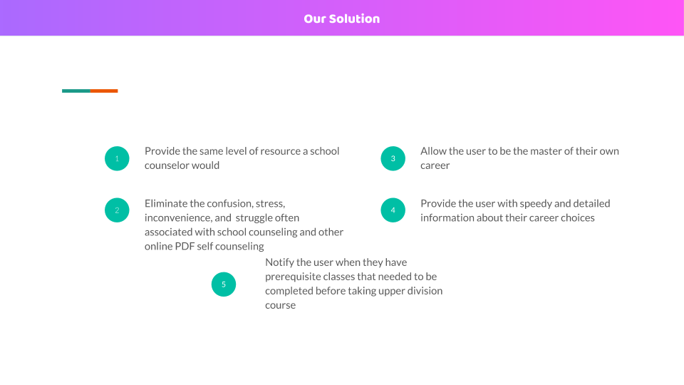

# Target Audience

* Community college students
* College counselors
* Dual enrolled high school students
* Prospective students

# Overview

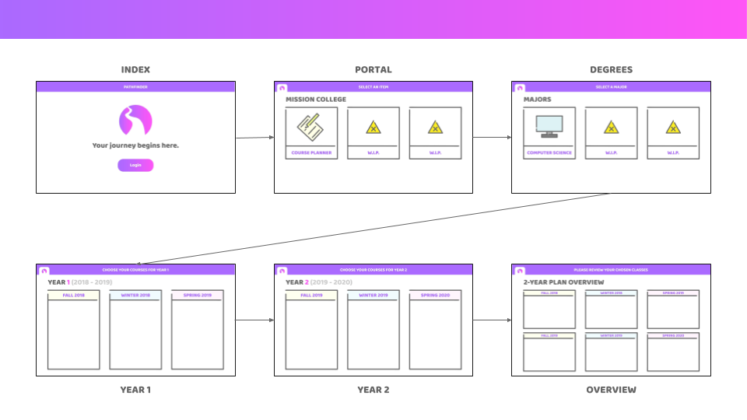

# Business Model

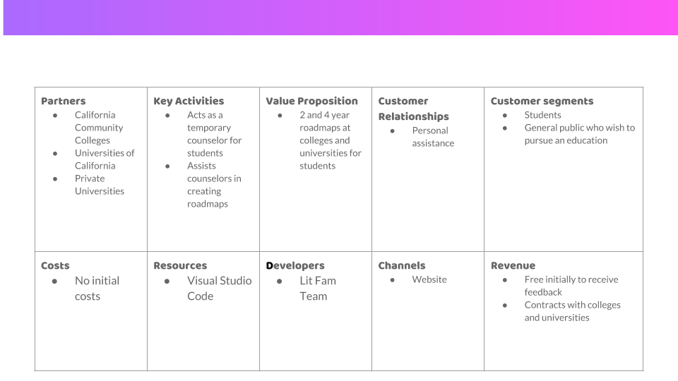

# Code

## Index

1. <!DOCTYPE html>
2. <HTML>
3. <head>
4. <title>
5. Pathfinder 1.0
6. </title>
7. </head>
8. <style>
9. body {font-family: Arial, Helvetica, sans-serif;}
10. form {border: 3px solid #f1f1f1;}
11. input[type=text], input[type=password] {
12. width: 100%;
13. padding: 12px 20px;
14. margin: 8px 0;
15. display: inline-block;
16. border: 1px solid #ccc;
17. box-sizing: border-box;
18. }
19. h1 {
20. font-family: Arial, Helvetica, sans-serif;
21. background-color: #AB6AFF;
22. text-align: center;
23. border-left: 0;
24. padding: 10px;
25. overflow: hidden;
26. color:white;
27. }
28. #img1:hover {
29. opacity: 0.8;
30. }
31. .imgcontainer {
32. text-align: center;
33. margin: 24px 0 12px 0;
34. }
35. img.avatar {
36. width: 30%;
37. border-radius: 100%;
38. }
39. .container {
40. padding: 16px;
41. }
42. span.psw {
43. float: right;
44. padding-top: 16px;
45. }
46. </style>
47. <h1>PATHFINDER</h1>
48. <body>
49. <div class="imgcontainer">
50. <img src="images/index_logo.png" alt="Avatar" class="avatar">
51. </div>
52. <div class="container">
53. <label for="uname"><b>Username</b></label>
54. <input type="text" placeholder="Enter Username" name="uname" required>
55. <label for="psw"><b>Password</b></label>
56. <input type="password" placeholder="Enter Password" name="psw" required>
58. <div class ="imgcontainer">
59. <a href="portal.html"><img src="images/pf_login_button.png" alt="login_button" id="img1" width="250" height="100"></a>
60. </div>
61. <br>
62. <label>
63. <input type="checkbox" checked="checked" name="remember"> Remember me
64. </label>
65. <p style="text-align: center";>Partnered with Mission College</p>
66. </div>
67. </body>
68. </HTML>

## Portal

1. <!DOCTYPE html>
2. <html>
3. <head>
4. <title>Student Portal</title>
5. </head>
6. <style>
7. body {font-family: Arial, Helvetica, sans-serif;}
8. form {border: 3px solid #f1f1f1;}
9. h1 {
10. font-family: Arial, Helvetica, sans-serif;
11. background-color: #AB6AFF;
12. text-align: center;
13. border-left: 0;
14. padding: 10px;
15. overflow: hidden;
16. color:white;
17. }
18. .button {
19. background-color: #FF55F6;
20. border: none;
21. color: rgb(113, 19, 235);
22. padding: 100px 50px;
23. text-align: center;
24. text-decoration: none;
25. display: inline-block;
26. font-size: 65px;
27. margin: 4px 2px;
28. cursor: pointer;
29. max-width: 350px;
30. }
31. #img1:hover {
32. opacity: 0.8;
33. }
34. .imgcontainer {
35. margin: 24px 0 12px 0;
36. }
37. img.avatar {
38. width: 30%;
39. border-radius: 100%;
40. }
41. .container {
42. padding: 16px;
43. }
44. h.test3{
45. font: 70px Helvetica;
46. }
47. </style>
48. <h1>PATHFINDER</h1>
49. <body>
50. <h class = "test3">Tools</h>
51. <br>
52. <hr>
53. <br>
54. <div class ="imgcontainer">
55. <a href="page3.html"><img src="images/pf_cp_button.jpg" alt="login_button" id="img1" width="500" height="500"></a>
56. <a href=""><img src="images/pf_wip_button.jpg" alt="wip_button" id="img1" width="500" height="500"></a>
57. <a href=""><img src="images/pf_wip_button.jpg" alt="wip_button" id="img1" width="500" height="500"></a>
58. </div>
59. <br>
60. <br>
61. <p style="text-align: center";>Partnered with Mission College</p>
62. </body>
63. </html>

## Page3

1. <!DOCTYPE html>
2. <html>
3. <head>
4. <title>Major Selector</title>
5. </head>
6. <style>
7. body {font-family: Arial, Helvetica, sans-serif;}
8. form {border: 3px solid #f1f1f1;}
9. h1 {
10. font-family: Arial, Helvetica, sans-serif;
11. background-color: #AB6AFF;
12. text-align: center;
13. border-left: 0;
14. padding: 10px;
15. overflow: hidden;
16. color:white;
17. }
18. .button {
19. background-color: #FF55F6;
20. border: none;
21. color: rgb(113, 19, 235);
22. padding: 100px 50px;
23. text-align: center;
24. text-decoration: none;
25. display: inline-block;
26. font-size: 65px;
27. margin: 4px 2px;
28. cursor: pointer;
29. max-width: 350px;
30. }
31. #img1:hover {
32. opacity: 0.8;
33. }
34. .imgcontainer {
35. margin: 24px 0 12px 0;
36. }
37. img.avatar {
38. width: 30%;
39. border-radius: 100%;
40. }
41. .container {
42. padding: 16px;
43. }
44. h.test3{
45. font: 70px Helvetica;
46. }
47. </style>
48. <h1>PATHFINDER</h1>
49. <body>
50. <h class = "test3">Select Degree Type</h>
51. <br>
52. <hr>
53. <br>
54. <div class ="imgcontainer">
55. <a href="page4.html"><img src="images/pf_2y_button.jpg" alt="cs_button" id="img1" width="500" height="500"></a>
56. <a href=""><img src="images/pf_asc_button.jpg" alt="wip_button" id="img1" width="500" height="500"></a>
57. <a href=""><img src="images/pf_cert_button.jpg" alt="wip_button" id="img1" width="500" height="500"></a>
58. </div>
59. <br>
60. <br>
61. <p style="text-align: center";>Partnered with Mission College</p>
62. </body>
63. </html>

## Page4

1. <!DOCTYPE html>
2. <html>
3. <head>
4. <title>Major Selector</title>
5. </head>
6. <style>
7. body {font-family: Arial, Helvetica, sans-serif;}
8. form {border: 3px solid #f1f1f1;}
9. h1 {
10. font-family: Arial, Helvetica, sans-serif;
11. background-color: #AB6AFF;
12. text-align: center;
13. border-left: 0;
14. padding: 10px;
15. overflow: hidden;
16. color:white;
17. }
18. .button {
19. background-color: #FF55F6;
20. border: none;
21. color: rgb(113, 19, 235);
22. padding: 100px 50px;
23. text-align: center;
24. text-decoration: none;
25. display: inline-block;
26. font-size: 65px;
27. margin: 4px 2px;
28. cursor: pointer;
29. max-width: 350px;
30. }
31. #img1:hover {
32. opacity: 0.8;
33. }
34. .imgcontainer {
35. margin: 24px 0 12px 0;
36. }
37. img.avatar {
38. width: 30%;
39. border-radius: 100%;
40. }
41. .container {
42. padding: 16px;
43. }
44. h.test3{
45. font: 70px Helvetica;
46. }
47. </style>
48. <h1>PATHFINDER</h1>
49. <body>
50. <h class = "test3">Select a Transfer Major</h>
51. <br>
52. <hr>
53. <br>
54. <div class ="imgcontainer">
55. <a href="year1.html"><img src="images/pf_cs_button.jpg" alt="login_button" id="img1" width="500" height="500"></a>
56. <a href=""><img src="images/pf_wip_button.jpg" alt="wip_button" id="img1" width="500" height="500"></a>
57. <a href=""><img src="images/pf_wip_button.jpg" alt="wip_button" id="img1" width="500" height="500"></a>
58. </div>
59. <br>
60. <br>
61. <p style="text-align: center";>Partnered with Mission College</p>
62. </body>
63. </html>

## Year1

1. <!DOCTYPE html>
2. <html>
3. <head>
4. <script src="https://ajax.googleapis.com/ajax/libs/angularjs/1.6.4/angular.min.js"></script>
5. <style>
6. .equalDivide tr td {
7. width: 25%;
8. }
9. h1.he {
10. font-family: Arial, Helvetica, sans-serif;
11. background-color: #AB6AFF;
12. text-align: center;
13. border-left: 0;
14. padding: 10px;
15. overflow: hidden;
16. color:white;
17. }
18. #courses {
19. font-family: "Trebuchet MS", Arial, Helvetica, sans-serif;
20. border-collapse: collapse;
21. width: 100%;
22. }
23. #courses td, #courses th {
24. border: 1px solid #ddd;
25. padding: 8px;
26. }
27. #courses tr:nth-child(even) {
28. background-color: #f2f2f2;
29. }
30. #courses tr:hover {
31. background-color: #ddd;
32. }
33. #courses th {
34. padding-top: 12px;
35. padding-bottom: 12px;
36. text-align: left;
37. background-color: #AB6AFF;
38. color: white;
39. }
40. .button {
41. border: none;
42. color: #FF55F6;
43. padding: 15px 32px;
44. text-align: center;
45. text-decoration: none;
46. display: inline-block;
47. font-size: 16px;
48. margin: 4px 2px;
49. cursor: pointer;
50. }
51. .btn-link {
52. background-color: #FF55F6;
53. border: none;
54. color: white;
55. padding: 15px 32px;
56. text-align: center;
57. text-decoration: none;
58. display: inline-block;
59. font-size: 16px;
60. margin: 4px 2px;
61. cursor: pointer;
62. }
63. </style>
64. </head>
65. <body>
66. <h1 class="he">PATHFINDER</h1>
67. <br>
68. <h1 style="color: black;">Year 1 (2018 - 2019)</h1>
69. <form name="myform" method="POST" action="" onsubmit="dosubmit()">
70. <table id="courses" class="equalDivide" cellpadding="0" cellspacing="0" width="100%" border="0">
71. <tr>
72. <th>Fall</th>
73. <th>Winter</th>
74. <th>Spring</th>
75. </tr>
76. <tr>
77. <td>
78. <select id="ddlCourses_fall_1" onchange="getData(this)"></select>
79. </td>
80. <td>
81. <select id="ddlCourses_winter_1" onchange="getData(this)"></select>
82. </td>
83. <td>
84. <select id="ddlCourses_spring_1" onchange="getData(this)"></select>
85. </td>
86. </tr>
87. <tr>
88. <td>
89. <select id="ddlCourses_fall_2" onchange="getData(this)"></select>
90. </td>
91. <td>
92. <select id="ddlCourses_winter_2" onchange="getData(this)"></select>
93. </td>
94. <td>
95. <select id="ddlCourses_spring_2" onchange="getData(this)"></select>
96. </td>
97. </tr>
98. <tr>
99. <td>
100. <select id="ddlCourses_fall_3" onchange="getData(this)"></select>
101. </td>
102. <td>
103. <select id="ddlCourses_winter_3" onchange="getData(this)"></select>
104. </td>
105. <td>
106. <select id="ddlCourses_spring_3" onchange="getData(this)"></select>
107. </td>
108. </tr>
109. </table>
110. <p id="demo"></p>
111. <button type="submit" name="your_name" value="your_value" class="btn-link">Next</button>
112. </form>
113. <script type="text/javascript">
114. function dosubmit() {
115. //alert(ddlCourses_fall_1.options[ddlCourses_fall_1.selectedIndex].value)
116. //var selectedValue = ddlCourses_fall_1.options[ddlCourses_fall_1.selectedIndex].value
117. //var selectedValues = [];
118. //selectedValues.push(selectedValue);
119. //selectedValues.push(selectedValue);
120. var fall_1 = ddlCourses_fall_1.options[ddlCourses_fall_1.selectedIndex];
121. var fall_2 = ddlCourses_fall_2.options[ddlCourses_fall_2.selectedIndex];
122. var fall_3 = ddlCourses_fall_3.options[ddlCourses_fall_3.selectedIndex];
123. var winter_1 = ddlCourses_winter_1.options[ddlCourses_winter_1.selectedIndex];
124. var winter_2 = ddlCourses_winter_2.options[ddlCourses_winter_2.selectedIndex];
125. var winter_3 = ddlCourses_winter_3.options[ddlCourses_winter_3.selectedIndex];
126. var spring_1 = ddlCourses_spring_1.options[ddlCourses_spring_1.selectedIndex];
127. var spring_2 = ddlCourses_spring_2.options[ddlCourses_spring_2.selectedIndex];
128. var spring_3 = ddlCourses_spring_3.options[ddlCourses_spring_3.selectedIndex];
129. var selectedCourses = [
130. { Course: 0, CourseID: fall_1.value, CourseName: fall_1.innerHTML },
131. { Course: 1, CourseID: winter_1.value, CourseName: winter_1.innerHTML },
132. { Course: 2, CourseID: spring_1.value, CourseName: spring_1.innerHTML },
133. { Course: 3, CourseID: fall_2.value, CourseName: fall_2.innerHTML },
134. { Course: 4, CourseID: winter_2.value, CourseName: winter_2.innerHTML },
135. { Course: 5, CourseID: spring_2.value, CourseName: spring_2.innerHTML },
136. { Course: 6, CourseID: fall_3.value, CourseName: fall_3.innerHTML },
137. { Course: 7, CourseID: winter_3.value, CourseName: winter_3.innerHTML },
138. { Course: 8, CourseID: spring_3.value, CourseName: spring_3.innerHTML },
139. { Course: 9, CourseID: "" },
140. { Course: 10, CourseID: "" },
141. { Course: 11, CourseID: "" },
142. { Course: 12, CourseID: "" },
143. { Course: 13, CourseID: "" },
144. { Course: 14, CourseID: "" },
145. { Course: 15, CourseID: "" },
146. { Course: 16, CourseID: "" },
147. { Course: 17, CourseID: "" }
148. ];
149. var json = JSON.stringify({ "selected_courses": selectedCourses });
150. document.myform.action = "year2.html?" + json;
151. window.event.returnValue = true;
152. }
153. var demo = document.getElementById("demo")
154. var ddlCourses_fall_1 = document.getElementById("ddlCourses_fall_1")
155. var ddlCourses_fall_2 = document.getElementById("ddlCourses_fall_2")
156. var ddlCourses_fall_3 = document.getElementById("ddlCourses_fall_3")
157. var ddlCourses_winter_1 = document.getElementById("ddlCourses_winter_1")
158. var ddlCourses_winter_2 = document.getElementById("ddlCourses_winter_2")
159. var ddlCourses_winter_3 = document.getElementById("ddlCourses_winter_3")
160. var ddlCourses_spring_1 = document.getElementById("ddlCourses_spring_1")
161. var ddlCourses_spring_2 = document.getElementById("ddlCourses_spring_2")
162. var ddlCourses_spring_3 = document.getElementById("ddlCourses_spring_3")
163. //Build an array containing Courses records.
164. var courses = [
165. { CourseID: 0, Name: "Select a course" },
166. { CourseID: 1, Name: "Math 03A" },
167. { CourseID: 2, Name: "Math 03B" },
168. { CourseID: 3, Name: "Math 04A" },
169. { CourseID: 4, Name: "Math 04B" },
170. { CourseID: 5, Name: "Math 04C" },
171. { CourseID: 6, Name: "PHYS 04A" },
172. { CourseID: 7, Name: "PHYS 04B" },
173. { CourseID: 8, Name: "PHYS 04C" },
174. { CourseID: 9, Name: "CHEM 01A" },
175. { CourseID: 10, Name: "ENG 01A" },
176. { CourseID: 11, Name: "ENG 01B" },
177. { CourseID: 12, Name: "CIS 037A - Introduction to C Programming" },
178. { CourseID: 13, Name: "CIS 043 - Software Development With Java" },
179. { CourseID: 14, Name: "CIS 044 - Introduction to Data Structures Using Java" },
180. { CourseID: 15, Name: "CIS 040 - C++ Programming" },
181. { CourseID: 16, Name: "CIS 039 - Intro to Computer Systems" },
182. { CourseID: 17, Name: "CIS 086 - Web Development with PHP and MySQL" },
183. { CourseID: 18, Name: "CIS 045 Linux Essentials I" },
184. { CourseID: 19, Name: "Math 19" },
185. ];
186. PopulateDropDownList(ddlCourses_fall_1, courses);
187. PopulateDropDownList(ddlCourses_fall_2, courses);
188. PopulateDropDownList(ddlCourses_fall_3, courses);
189. PopulateDropDownList(ddlCourses_winter_1, courses);
190. PopulateDropDownList(ddlCourses_winter_2, courses);
191. PopulateDropDownList(ddlCourses_winter_3, courses);
192. PopulateDropDownList(ddlCourses_spring_1, courses);
193. PopulateDropDownList(ddlCourses_spring_2, courses);
194. PopulateDropDownList(ddlCourses_spring_3, courses);
195. optionSelection(ddlCourses_fall_1, 10)
196. optionSelection(ddlCourses_fall_2, 1)
197. optionSelection(ddlCourses_fall_3, 12)
198. optionSelection(ddlCourses_winter_1, 11)
199. optionSelection(ddlCourses_winter_2, 2)
200. optionSelection(ddlCourses_winter_3, 13)
201. optionSelection(ddlCourses_spring_1, 9)
202. optionSelection(ddlCourses_spring_2, 3)
203. optionSelection(ddlCourses_spring_3, 14)
205. function optionSelection(ddl, id) {
206. ddl.getElementsByTagName('option')[id].selected = 'selected'
207. }
208. function PopulateDropDownList(selection, courses) {
209. removeOptions(selection);
210. for (var i = 0; i < courses.length; i++) {
211. var option = document.createElement("OPTION");
212. //Set Courses Name in Text part.
213. option.innerHTML = courses[i].Name;
214. //Set CoursesId in Value part.
215. option.value = courses[i].CourseID;
216. //Add the Option element to DropDownList.
217. selection.options.add(option);
218. }
219. }
220. const removeArrayItem = (arr, itemToRemove) => {
221. return arr.filter(item => item !== itemToRemove)
222. }
223. var selectedValues = [];
224. function getData(dropdown) {
225. //var selectedValue = dropdown.options[dropdown.selectedIndex].value;
226. //var selectedInnerHTML = dropdown.options[dropdown.selectedIndex].innerHTML;
227. //demo.innerText = "Selected Course: " + selectedInnerHTML + "\n";
228. //if (selectedValue != 0) {
229. // if (!selectedValues.includes(selectedValue)) {
230. // selectedValues.push(selectedValue);
231. // }
232. //}
233. //else { // equals 0
234. //}
235. //for (var i = 0; i < courses.length; i++) {
236. // //demo.innerText = "courses: " + selectedValues.includes(courses[1].CourseID) + "\n";
237. // demo.innerText = "courses: " +courses[1].CourseID + "\n";
238. // //if (!selectedValues.includes(courses[i].CourseID)) {
239. // // newCourses.push(courses[i]);
240. // //}
241. //}
242. ////}
243. ////for (i = 0 ; i < selectedValues.length ; i++) {
244. //// selectedIndex = selectedValues[i];
245. //// for (j = 0 ; j < newCourses.length ; j++) {
246. //// if (selectedIndex == newCourses[j].CourseID) {
247. //// newCourses.splice(selectedValue, 1);
248. //// }
249. //// }
250. ////}
251. ////
252. ////if (selectedValue != 0){
253. //// newCourses.splice(selectedValue, 1);
254. ////}
255. //PopulateIfNull(ddlCourses_fall_1, newCourses);
256. //PopulateIfNull(ddlCourses_fall_2, newCourses);
257. //PopulateIfNull(ddlCourses_fall_3, newCourses);
258. //PopulateIfNull(ddlCourses_winter_1, newCourses);
259. //PopulateIfNull(ddlCourses_winter_2, newCourses);
260. //PopulateIfNull(ddlCourses_winter_3, newCourses);
261. //PopulateIfNull(ddlCourses_spring_1, newCourses);
262. //PopulateIfNull(ddlCourses_spring_2, newCourses);
263. //PopulateIfNull(ddlCourses_spring_3, newCourses);
264. }
265. function onClick() {
266. //demo.innerText = "--------------------------------\n";
267. //for (i = 0 ; i < selectedValues.length ; i++) {
268. // demo.innerText += "" + selectedValues[i] + "\n";
269. //}
270. //for (i = 0 ; i < newCourses.length ; i++) {
271. // demo.innerText += " " + newCourses[i].Name + "\n"
272. //}
273. }
274. function PopulateIfNull(ddl, newCourses1) {
275. if (ddl.options[ddl.selectedIndex].value == 0) {
276. PopulateDropDownList(ddl, newCourses1)
277. }
278. }
279. function removeOptions(selectbox) {
280. var i;
281. for (i = selectbox.options.length - 1 ; i >= 0 ; i--) {
282. selectbox.remove(i);
283. }
284. }
285. </script>
286. </body>
287. </html>

## Year2

1. <!DOCTYPE html>
2. <html>
3. <head>
4. <script src="https://ajax.googleapis.com/ajax/libs/angularjs/1.6.4/angular.min.js"></script>
5. <style>
6. .equalDivide tr td {
7. width: 25%;
8. }
9. h1.he {
10. font-family: Arial, Helvetica, sans-serif;
11. background-color: #AB6AFF;
12. text-align: center;
13. border-left: 0;
14. padding: 10px;
15. overflow: hidden;
16. color:white;
17. }
19. #courses {
20. font-family: "Trebuchet MS", Arial, Helvetica, sans-serif;
21. border-collapse: collapse;
22. width: 100%;
23. }
24. #courses td, #courses th {
25. border: 1px solid #ddd;
26. padding: 8px;
27. }
28. #courses tr:nth-child(even) {
29. background-color: #f2f2f2;
30. }
31. #courses tr:hover {
32. background-color: #ddd;
33. }
34. #courses th {
35. padding-top: 12px;
36. padding-bottom: 12px;
37. text-align: left;
38. background-color: #AB6AFF;
39. color: white;
40. }
41. .button {
42. border: none;
43. color: white;
44. padding: 15px 32px;
45. text-align: center;
46. text-decoration: none;
47. display: inline-block;
48. font-size: 16px;
49. margin: 4px 2px;
50. cursor: pointer;
51. }
52. .btn-link {
53. background-color: #FF55F6;
54. border: none;
55. color: white;
56. padding: 15px 32px;
57. text-align: center;
58. text-decoration: none;
59. display: inline-block;
60. font-size: 16px;
61. margin: 4px 2px;
62. cursor: pointer;
63. }
64. </style>
65. </head>
66. <body>
67. <h1 class="he">PATHFINDER</h1>
68. <br>
69. <h1 style="color:black;">Year 2 (2019 -2020)</h1>
70. <form name="myform" method="POST" action="" onsubmit="dosubmit()">
71. <table id="courses" class="equalDivide" cellpadding="0" cellspacing="0" width="100%" border="0">
72. <tr>
73. <th>Fall</th>
74. <th>Winter</th>
75. <th>Spring</th>
76. </tr>
77. <tr>
78. <td>
79. <select id="ddlCourses_fall_1" onchange="getData(this)"></select>
80. </td>
81. <td>
82. <select id="ddlCourses_winter_1" onchange="getData(this)"></select>
83. </td>
84. <td>
85. <select id="ddlCourses_spring_1" onchange="getData(this)"></select>
86. </td>
87. </tr>
88. <tr>
89. <td>
90. <select id="ddlCourses_fall_2" onchange="getData(this)"></select>
91. </td>
92. <td>
93. <select id="ddlCourses_winter_2" onchange="getData(this)"></select>
94. </td>
95. <td>
96. <select id="ddlCourses_spring_2" onchange="getData(this)"></select>
97. </td>
98. </tr>
99. <tr>
100. <td>
101. <select id="ddlCourses_fall_3" onchange="getData(this)"></select>
102. </td>
103. <td>
104. <select id="ddlCourses_winter_3" onchange="getData(this)"></select>
105. </td>
106. <td>
107. <select id="ddlCourses_spring_3" onchange="getData(this)"></select>
108. </td>
109. </tr>
110. </table>
111. <p id="demo"></p>
112. <button type="submit" name="your_name" value="your_value" class="btn-link">Next</button>
113. </form>
114. <script type="text/javascript">
115. var selectedCourses
116. var string = window.location.href;
117. var getit = new Array();
118. getit = string.split("?");
119. var json = unescape(getit[1]);
120. obj = JSON.parse(json);
121. selectedCourses = obj.selected_courses;
122. function dosubmit() {
123. course_9 = ddlCourses_fall_1.options[ddlCourses_fall_1.selectedIndex];
124. course_10 = ddlCourses_winter_1.options[ddlCourses_winter_1.selectedIndex];
125. course_11 = ddlCourses_spring_1.options[ddlCourses_spring_1.selectedIndex];
126. course_12 = ddlCourses_fall_2.options[ddlCourses_fall_2.selectedIndex];
127. course_13 = ddlCourses_winter_2.options[ddlCourses_winter_2.selectedIndex];
128. course_14 = ddlCourses_spring_2.options[ddlCourses_spring_2.selectedIndex];
129. course_15= ddlCourses_fall_3.options[ddlCourses_fall_1.selectedIndex];
130. course_16 = ddlCourses_winter_3.options[ddlCourses_winter_3.selectedIndex];
131. course_17 = ddlCourses_spring_3.options[ddlCourses_spring_3.selectedIndex];
133. var year2_selectedCourses = [
134. { Course: 0, CourseID: selectedCourses[0].CourseID ,CourseName: selectedCourses[0].CourseName },
135. { Course: 1, CourseID: selectedCourses[1].CourseID, CourseName: selectedCourses[1].CourseName },
136. { Course: 2, CourseID: selectedCourses[2].CourseID, CourseName: selectedCourses[2].CourseName },
137. { Course: 3, CourseID: selectedCourses[3].CourseID, CourseName: selectedCourses[3].CourseName },
138. { Course: 4, CourseID: selectedCourses[4].CourseID, CourseName: selectedCourses[4].CourseName },
139. { Course: 5, CourseID: selectedCourses[5].CourseID, CourseName: selectedCourses[5].CourseName },
140. { Course: 6, CourseID: selectedCourses[6].CourseID, CourseName: selectedCourses[6].CourseName },
141. { Course: 7, CourseID: selectedCourses[7].CourseID, CourseName: selectedCourses[7].CourseName },
142. { Course: 8, CourseID: selectedCourses[8].CourseID, CourseName: selectedCourses[8].CourseName },
143. { Course: 9, CourseID: course_9.value, CourseName: course_9.innerHTML },
144. { Course: 10, CourseID: course_10.value, CourseName: course_10.innerHTML },
145. { Course: 11, CourseID: course_11.value, CourseName: course_11.innerHTML },
146. { Course: 12, CourseID: course_12.value, CourseName: course_12.innerHTML },
147. { Course: 13, CourseID: course_13.value, CourseName: course_13.innerHTML },
148. { Course: 14, CourseID: course_14.value, CourseName: course_14.innerHTML },
149. { Course: 15, CourseID: course_15.value, CourseName: course_15.innerHTML },
150. { Course: 16, CourseID: course_16.value, CourseName: course_16.innerHTML },
151. { Course: 17, CourseID: course_17.value, CourseName: course_17.innerHTML }
152. ];
153. var json = JSON.stringify({ "selected_courses": year2_selectedCourses });
154. document.myform.action = "final_plan.html?" + json;
155. window.event.returnValue = true;
156. }
157. var demo = document.getElementById("demo")
158. var ddlCourses_fall_1 = document.getElementById("ddlCourses_fall_1")
159. var ddlCourses_fall_2 = document.getElementById("ddlCourses_fall_2")
160. var ddlCourses_fall_3 = document.getElementById("ddlCourses_fall_3")
161. var ddlCourses_winter_1 = document.getElementById("ddlCourses_winter_1")
162. var ddlCourses_winter_2 = document.getElementById("ddlCourses_winter_2")
163. var ddlCourses_winter_3 = document.getElementById("ddlCourses_winter_3")
164. var ddlCourses_spring_1 = document.getElementById("ddlCourses_spring_1")
165. var ddlCourses_spring_2 = document.getElementById("ddlCourses_spring_2")
166. var ddlCourses_spring_3 = document.getElementById("ddlCourses_spring_3")
167. //Build an array containing Courses records.
168. var courses = [
169. { CourseID: 0, Name: "Select a course" },
170. { CourseID: 1, Name: "Math 03A" },
171. { CourseID: 2, Name: "Math 03B" },
172. { CourseID: 3, Name: "Math 04A" },
173. { CourseID: 4, Name: "Math 04B" },
174. { CourseID: 5, Name: "Math 04C" },
175. { CourseID: 6, Name: "PHYS 04A" },
176. { CourseID: 7, Name: "PHYS 04B" },
177. { CourseID: 8, Name: "PHYS 04C" },
178. { CourseID: 9, Name: "CHEM 01A" },
179. { CourseID: 10, Name: "ENG 01A" },
180. { CourseID: 11, Name: "ENG 01B" },
181. { CourseID: 12, Name: "CIS 037A - Introduction to C Programming" },
182. { CourseID: 13, Name: "CIS 043 - Software Development With Java" },
183. { CourseID: 14, Name: "CIS 044 - Introduction to Data Structures Using Java" },
184. { CourseID: 15, Name: "CIS 040 - C++ Programming" },
185. { CourseID: 16, Name: "CIS 039 - Intro to Computer Systems" },
186. { CourseID: 17, Name: "CIS 086 - Web Development with PHP and MySQL" },
187. { CourseID: 18, Name: "CIS 045 Linux Essentials I" },
188. { CourseID: 19, Name: "Math 19" }
189. ];
190. PopulateDropDownList(ddlCourses_fall_1, courses);
191. PopulateDropDownList(ddlCourses_fall_2, courses);
192. PopulateDropDownList(ddlCourses_fall_3, courses);
193. PopulateDropDownList(ddlCourses_winter_1, courses);
194. PopulateDropDownList(ddlCourses_winter_2, courses);
195. PopulateDropDownList(ddlCourses_winter_3, courses);
196. PopulateDropDownList(ddlCourses_spring_1, courses);
197. PopulateDropDownList(ddlCourses_spring_2, courses);
198. PopulateDropDownList(ddlCourses_spring_3, courses);
199. optionSelection(ddlCourses_fall_1,4)
200. optionSelection(ddlCourses_fall_2,6)
201. optionSelection(ddlCourses_fall_3, 15)
202. optionSelection(ddlCourses_winter_1, 5)
203. optionSelection(ddlCourses_winter_2, 7)
204. optionSelection(ddlCourses_winter_3, 17)
205. optionSelection(ddlCourses_spring_1, 19)
206. optionSelection(ddlCourses_spring_2, 8)
207. optionSelection(ddlCourses_spring_3, 18)
208. function optionSelection(ddl, id) {
209. ddl.getElementsByTagName('option')[id].selected = 'selected'
210. }
211. function PopulateDropDownList(selection, courses) {
212. removeOptions(selection);
213. for (var i = 0; i < courses.length; i++) {
214. var option = document.createElement("OPTION");
215. //Set Courses Name in Text part.
216. option.innerHTML = courses[i].Name;
217. //Set CoursesId in Value part.
218. option.value = courses[i].CourseID;
219. //Add the Option element to DropDownList.
220. selection.options.add(option);
221. }
222. }
223. const removeArrayItem = (arr, itemToRemove) => {
224. return arr.filter(item => item !== itemToRemove)
225. }
226. var selectedValues = [];
227. function getData(dropdown) {
229. }
230. function onClick() {
232. }
233. function PopulateIfNull(ddl, newCourses1) {
234. if (ddl.options[ddl.selectedIndex].value == 0) {
235. PopulateDropDownList(ddl, newCourses1)
236. }
237. }
238. function removeOptions(selectbox) {
239. var i;
240. for (i = selectbox.options.length - 1 ; i >= 0 ; i--) {
241. selectbox.remove(i);
242. }
243. }
244. </script>
245. </body>
246. </html>

## Final_Plan

1. <!DOCTYPE html>
2. <html>
3. <head>
4. <script src="https://ajax.googleapis.com/ajax/libs/angularjs/1.6.4/angular.min.js"></script>
5. <style>
6. .equalDivide tr td {
7. width: 25%;
8. }
9. h1.he {
10. font-family: Arial, Helvetica, sans-serif;
11. background-color: #AB6AFF;
12. text-align: center;
13. border-left: 0;
14. padding: 10px;
15. overflow: hidden;
16. color:white;
17. }
18. #courses {
19. font-family: "Trebuchet MS", Arial, Helvetica, sans-serif;
20. border-collapse: collapse;
21. width: 100%;
22. }
23. #courses td, #courses th {
24. border: 1px solid #ddd;
25. padding: 8px;
26. }
27. #courses tr:nth-child(even) {
28. background-color: #f2f2f2;
29. }
30. #courses tr:hover {
31. background-color: #ddd;
32. }
33. #courses th {
34. padding-top: 12px;
35. padding-bottom: 12px;
36. text-align: left;
37. background-color: #AB6AFF;
38. color: white;
39. }
40. .button {
41. border: none;
42. color: white;
43. padding: 15px 32px;
44. text-align: center;
45. text-decoration: none;
46. display: inline-block;
47. font-size: 16px;
48. margin: 4px 2px;
49. cursor: pointer;
50. }
51. .btn-link {
52. background-color: #FF55F6;
53. border: none;
54. color: white;
55. padding: 15px 32px;
56. text-align: center;
57. text-decoration: none;
58. display: inline-block;
59. font-size: 16px;
60. margin: 4px 2px;
61. cursor: pointer;
62. }
63. </style>
64. </head>
65. <body>
66. <h1 class="he">PATHFINDER</h1>
67. <br>
68. <h1 style="color:black;">Year 1 (2018 - 2019)</h1>
69. <form name="myform" method="POST" action="" onsubmit="dosubmit()">
70. <table id="courses" class="equalDivide" cellpadding="0" cellspacing="0" width="100%" border="0">
71. <tr>
72. <th>Fall</th>
73. <th>Winter</th>
74. <th>Spring</th>
75. </tr>
76. <tr>
77. <td>
78. <p id="course_0">Hello World!</p>
79. </td>
80. <td>
81. <p id="course_1">Hello World!</p>
82. </td>
83. <td>
84. <p id="course_2">Hello World!</p>
85. </td>
86. </tr>
87. <tr>
88. <td>
89. <p id="course_3">Hello World!</p>
90. </td>
91. <td>
92. <p id="course_4">Hello World!</p>
93. </td>
94. <td>
95. <p id="course_5">Hello World!</p>
96. </td>
97. </tr>
98. <tr>
99. <td>
100. <p id="course_6">Hello World!</p>
101. </td>
102. <td>
103. <p id="course_7">Hello World!</p>
104. </td>
105. <td>
106. <p id="course_8">Hello World!</p>
107. </td>
108. </tr>
109. </table>
110. <h1 style="color:black;">Year 2 (2019 - 2020)</h1>
111. <table id="courses" class="equalDivide" cellpadding="0" cellspacing="0" width="100%" border="0">
112. <tr>
113. <th>Fall</th>
114. <th>Winter</th>
115. <th>Spring</th>
116. </tr>
117. <tr>
118. <td>
119. <p id="course_9">Hello World!</p>
120. </td>
121. <td>
122. <p id="course_10">Hello World!</p>
123. </td>
124. <td>
125. <p id="course_11">Hello World!</p>
126. </td>
127. </tr>
128. <tr>
129. <td>
130. <p id="course_12">Hello World!</p>
131. </td>
132. <td>
133. <p id="course_13">Hello World!</p>
134. </td>
135. <td>
136. <p id="course_14">Hello World!</p>
137. </td>
138. </tr>
139. <tr>
140. <td>
141. <p id="course_15">Hello World!</p>
142. </td>
143. <td>
144. <p id="course_16">Hello World!</p>
145. </td>
146. <td>
147. <p id="course_17">Hello World!</p>
148. </td>
149. </tr>
150. </table>
151. <script type="text/javascript">
152. var selectedCourses
153. var string = window.location.href;
154. var getit = new Array();
155. getit = string.split("?");
156. var json = unescape(getit[1]);
157. obj = JSON.parse(json);
158. selectedCourses = obj.selected_courses;
159. document.getElementById("course_0").innerHTML = selectedCourses[0].CourseName;
160. document.getElementById("course_1").innerHTML = selectedCourses[1].CourseName;
161. document.getElementById("course_2").innerHTML = selectedCourses[2].CourseName;
162. document.getElementById("course_3").innerHTML = selectedCourses[3].CourseName;
163. document.getElementById("course_4").innerHTML = selectedCourses[4].CourseName;
164. document.getElementById("course_5").innerHTML = selectedCourses[5].CourseName;
165. document.getElementById("course_6").innerHTML = selectedCourses[6].CourseName;
166. document.getElementById("course_7").innerHTML = selectedCourses[7].CourseName;
167. document.getElementById("course_8").innerHTML = selectedCourses[8].CourseName;
168. document.getElementById("course_9").innerHTML = selectedCourses[9].CourseName;
169. document.getElementById("course_10").innerHTML = selectedCourses[10].CourseName;
170. document.getElementById("course_11").innerHTML = selectedCourses[11].CourseName;
171. document.getElementById("course_12").innerHTML = selectedCourses[12].CourseName;
172. document.getElementById("course_13").innerHTML = selectedCourses[13].CourseName;
173. document.getElementById("course_14").innerHTML = selectedCourses[14].CourseName;
174. document.getElementById("course_15").innerHTML = selectedCourses[15].CourseName;
175. document.getElementById("course_16").innerHTML = selectedCourses[16].CourseName;
176. document.getElementById("course_17").innerHTML = selectedCourses[17].CourseName;
177. </script>
178. </body>
179. </html>